DIGITAL STUDENT MOVEMENT MONITORING SYSTEM

**A PROJECT REPORT**

**Submitted to**

**Visvesvaraya Technological University**

**BELAGAVI - 590 018**

**by**

**Ashwath G Bhat 4SU21AD009**

**Deviprasad 4SU21AD016**

**Prabhu Gouda Patil 4SU22AD401**

**Yathiraj 4SU22AD403**

**Under the guidance of**

**Mr. Amith K S**

**Assistant Professor**

**in partial fulfillment of the requirements for the award of the degree of**

**Bachelor of Engineering**



**Department of Artificial Intelligence and Data Science**

**SDM INSTITUTE OF TECHNOLOGY**

**UJIRE - 574 240**

**2024-2025**

**SDM Institute of Technology**

(Affiliated to Visvesvaraya Technological University, Belagavi)

**UJIRE – 574 240**

**Department of Artificial Intelligence and Data Science**

***Certificate***

Certified that the Project Work titled ‘**Digital Student Movement Monitoring System**’ is carried out by **Mr. Ashwath G Bhat**, USN: **4SU21AD009, Mr. Deviprasad**, USN: **4SU21AD016, Mr. Prabhu Gouda Patil**, USN: **4SU22AD401, Mr. Yathiraj**, USN: **4SU22AD403,** Bonafide students of SDM Institute of Technology, Ujire, in partial fulfillment for the award of the degree of **Bachelor of Engineering** in Artificial Intelligence and Data Science Engineering of Visvesvaraya Technological University, Belagavi during the year 2024-2025. It is certified that all the corrections/suggestions indicated for Internal Assessment have been incorporated in the report deposited in the departmental library. The project report has been approved as it satisfies the academic requirements in respect of project work prescribed for the said Degree.

**Mr. Amith K S Mrs. Veena Bhat Dr. Ashok Kumar T**

Asst. Professor and Guide Head of Department Principal

**External Viva**

**Name of the Examiners: Signature with Date**

1.

2.

**Abstract**

This project introduces an intelligent hostel management system that replaces the manual login/logout process with advanced face recognition and data analytics. By automating student entries and exits, the system records timestamps and allows students to select preset destinations with fixed return times. The traditional logbook system is inefficient and prone to human error, limiting real-time tracking and analysis. The proposed solution enhances security and operational efficiency with features like automated alerts, color-coded visual tracking, and data-driven insights, ensuring improved safety and effective administration.

**Acknowledgement**

It is our pleasure to express our heartfelt thanks to **Mr. Amith K S**, Assistant Professor, Department of Artificial Intelligence and Data Science Engineering, for his supervision and guidance which enabled us to understand and develop this project.

We are indebted to **Mrs. Veena Bhat**, Head of the Department and **Dr. Ashok Kumar T**, Principal, for their advice and suggestions at various stages of the work. We also extend our heartfelt gratitude to **Mr. Amith K S**, Project Coordinator for his assistance and the management of SDM Institute of Technology, Ujire, for providing us with a good learning environment, library and laboratory facilities.

Lastly, we take this opportunity to offer our regards to all of those who have supported us directly or indirectly in the successful completion of this project work.

Ashwath G Bhat: 4SU21AD009

Deviprasad: 4SU21AD016

Prabhu Gouda Patil: 4SU22AD401

Yathiraj: 4SU22AD403

**Table of Contents**

|  |  |  |
| --- | --- | --- |
|  |  | **Page No.** |
| **Abstract** | | **i** |
| **Acknowledgement** | | **ii** |
| **Table of Contents** | | **iii** |
| **List of Figures** | | **v** |
| **List of Tables** | | **vi** |
| **List of Abbreviations** | | **vii** |
| **Chapter 1** | **Introduction** | **1** |
| 1.1 | Project Overview | 1 |
| 1.2 | Problem Description | 1 |
| 1.3 | Objectives of the Present Study | 2 |
| 1.4 | Scope of the Project | 2 |
| 1.5 | Methodology Used | 3 |
| **Chapter 2** | **Literature Review** | **4** |
| 2.1 | Existing Systems or Technologies | 7 |
| 2.2 | Comparative Analysis of the Related Work | 7 |
| 2.3 | Summary | 9 |
| **Chapter 3** | **Software and Hardware Requirements** | **10** |
| 3.1 | Software Requirements | 10 |
| 3.2 | Hardware Requirements | 10 |
| **Chapter 4** | **System Design** | **11** |
| 4.1 | Architecture of the Proposed System | 11 |
| 4.2 | System Flowchart | 12 |
| 4.3 | Schema Diagram | 13 |
| **Chapter 5** | **System Implementation** | **16** |
| 5.1 | System Features | 16 |
| 5.2 | Algorithms and Techniques | 17 |
| 5.3 | Coding Standards and Practices | 17 |
| 5.4 | Pseudocode | 17 |
| **Chapter 6** | **Testing and Validation** | **22** |
| 6.1 | Testing Strategies | 22 |
| 6.2 | Test Cases and Results | 22 |
| 6.3 | Validation and Verification | 23 |
| **Chapter 7** | **Results and Discussions** | **27** |
| 7.1 | Outputs of the Project | 27 |
| 7.2 | Performance Analysis | 32 |
| 7.3 | Comparisons with Existing Solutions | 33 |
| **Chapter 8** | **Conclusion and Future Enhancements** | **36** |
| 8.1 | Future Enhancements | 36 |
| **References** | | **37** |
| **Plagiarism Report** | | **38** |
| **Personal Profile** | | **39** |

**List of Figures**

|  |  |  |
| --- | --- | --- |
|  | **Figure Name** | **Page No.** |
| Figure 4.1 | Architecture of the Proposed System | 11 |
| Figure 4.2 | System Flowchart | 12 |
| Figure 4.3 | Schema Diagram | 13 |
| Figure 7.1 | Login Page | 27 |
| Figure 7.2 | Supervisor Dashboard | 27 |
| Figure 7.3 | View Attendance Section | 28 |
| Figure 7.4 | Overtime Setting Page | 28 |
| Figure 7.5 | Admin Dashboard | 29 |
| Figure 7.6 | Warden Dashboard | 29 |
| Figure 7.7 | Add Student Form | 30 |
| Figure 7.8 | Picture Clicking and Training Section | 30 |
| Figure 7.9 | Attendance Pie Chart | 31 |
| Figure 7.10 | Attendance Desk Section | 31 |

**List of Tables**

|  |  |  |  |
| --- | --- | --- | --- |
|  | **Table Name** | **Page No.** | |
| Table 2.1 | Comparative Analysis | | 7 |
| Table 3.1 | Software Requirements | | 10 |
| Table 3.2 | Hardware Requirements | | 10 |
| Table 6.1 | Login and Password Testing and Validation | | 23 |
| Table 6.2 | Face recognition and Attendance Testing and Validation | | 25 |
| Table 7.1 | Unit Test Cases | | 32 |
| Table 7.2 | Comparison Test Cases | | 34 |

**List of Abbreviations**

|  |  |  |  |
| --- | --- | --- | --- |
|  | PCA | Principal Component Analysis | |
|  | SVM | Support Vector Machine |
|  | KNN | K-Nearest Neighbor |
|  | CNN | Convolutional Neural Networks |
|  | GAN | Generative Adversarial Networks |
|  | LBPH | Local Binary Pattern Histogram |
|  | AWS | Amazon Web Services |
|  | IoT | Internet of Things |
|  | DWT | Discrete Wavelet Transforms |
|  | DCT | Discrete Cosine Transform |
|  | RBF | Radial Basis Function |
|  | GPS | Global Positioning System |
|  | QR | Quick Response |
|  | YOLO | You Only Look Once |

**Chapter 1**

**Introduction**

The introduction section of a project report provides a brief overview of the project, its objectives, and the motivation behind it. It sets the context by explaining the problem statement and highlights the significance of the proposed solution in addressing real-world challenges.

* 1. **Project Overview**

In hostel environments, efficient and secure tracking of student movements is essential for safety. Traditional methods like manual logbooks are prone to human error and lack real-time monitoring, leading to delays and potential safety risks. The Digital Student Movement Monitoring System addresses these issues by using face recognition to automate login and logout processes. The system accurately identifies students, timestamps entries and exits, and allows them to select destinations with pre-set return times. If a student does not return on time, an automated alert is sent to both the student and the warden, enabling timely follow-up.

The system also includes real-time data analytics, which generate reports on movement patterns through visual graphs and tables. This data-driven approach helps administrators track trends, identify irregularities, and improve security decisions. With its combination of facial recognition, alerts, and analytics, the Digital Student Movement Monitoring System replaces outdated methods, enhancing safety and operational efficiency for hostel management.

**1.2 Problem Description**

Managing student movements in a hostel environment is a critical yet traditionally inefficient process. Most hostels rely on manual methods, such as registers or logbooks, to track student entries and exits. These methods are not only time-consuming but are also highly prone to human error, lack transparency, and fail to provide real-time monitoring or alerts in case of delayed returns. Additionally, such manual systems do not offer any actionable insights or analytical data for hostel authorities to assess patterns in student movements. As a result, there are several operational inefficiencies, including the inability to track students effectively, identify delays promptly, or send timely alerts to students or wardens when necessary.

**1.3 Objectives of the Present Study**

The Digital Student Movement Monitoring System aims to achieve the following objectives:

* **Automate Student Tracking**: Replace traditional manual systems with a digital platform that uses facial recognition to log students’ entry and exit times.
* **Enhance Accountability**: Maintain accurate, real-time records of student movements, ensuring transparency and minimizing errors.
* **Improve Safety Measures**: Notify wardens and students automatically through email alerts if a student fails to return within the specified time.
* **Simplify Operations**: Provide an efficient and user-friendly system that reduces administrative workload and streamlines hostel management.
* **Enable Data Insights**: Offer analytical tools to monitor patterns in student movements, identify late returns, and ensure compliance with hostel rules.

**1.4 Scope of the Project**

The **Digital Student Movement Monitoring System** provides an efficient and automated solution for managing student movements within hostel premises. Its scope includes:

* **Automation of Login/Logout**: The system automates the traditional manual process of recording student movements using face recognition technology, ensuring accurate and timestamped data entry.
* **Timely Notifications**: Alerts are sent to students and wardens when a student fails to return on time, improving accountability and enhancing safety.
* **Data Analysis**: The system offers data analysis features to monitor real-time student statuses, track late returns, and generate detailed reports, aiding in better decision-making.
* **User-Friendly Design**: The system is designed to integrate seamlessly with a web-based interface, allowing users to interact with the system through an intuitive and professional frontend.
* **Scalability**: The system can be adapted for use in various educational institutions and expanded to accommodate larger hostels with more students.
* **Improved Safety and Efficiency**: By digitizing movement tracking and providing timely alerts, the system enhances safety for students and streamlines the warden's administrative tasks.

**1.5 Methodology Used**

1. **Face Detection and Recognition Algorithm:** Face detection is achieved using the Haar Cascade algorithm, a machine learning-based approach designed to identify faces by detecting specific facial features through pre-trained classifiers. This algorithm is optimized for real-time applications, offering rapid and reliable detection.
2. **Automated Alerting and Notification System:** The system integrates a dynamic, rule-based alert mechanism that continuously tracks each student’s return time. If a student fails to return within the designated period, the system automatically generates and sends alert notifications to both the student and the warden. This real-time notification protocol enhances response times and supports a proactive approach to safety and accountability.
3. **Color-Coded Status Indicator and Visual Data Representation:** To improve visibility and accessibility, the system employs a color-coded status indicator to reflect students’ return times: green (on-time), yellow (slightly late), and red (significantly late). This visual categorization enables administrators to monitor real-time statuses at a glance, while the analytical component tracks movement trends, ensuring a comprehensive and easily interpretable dataset.

**Chapter 2**

**Literature Review**

A literature survey is a comprehensive examination of existing research and scholarly materials related to a specific topic or question. It involves identifying, evaluating, and synthesizing relevant studies to provide an overview of the current state of knowledge, highlight gaps, and establish the context for further research. By analyzing previous work, a literature survey helps to refine research questions, inform methodologies, and demonstrate an understanding of the field. It is an essential step in academic research that ensures the work contributes new insights rather than duplicating existing studies.

Gurlove Singh & Amit Kumar Goel, [1] "Face Detection and Recognition System using Digital Image Processing," propose that face recognition is a biometric technology used for identity authentication based on facial features. The process is divided into two phases: face detection, which is fast unless the face is far away, and face recognition, where the individual’s identity is confirmed. Two common techniques in face recognition are the Eigenface method, which uses Principal Component Analysis (PCA) to reduce the facial feature space, and the Fisherface method, which improves classification accuracy. This paper focuses on applying digital image processing to develop a robust face recognition system. These techniques help create an efficient and secure face recognition model.

Lixiang Li, Xiaohui Mu, Siying Li, and Haipeng Peng, [2] “A Review of Face Recognition Technology," provide a comprehensive analysis of the evolution and state of face recognition technology. The paper outlines key development stages, including early algorithms, artificial features, classifiers, and the transformative impact of deep learning. It explores challenges in real-world applications, such as illumination and expression variations, and highlights advancements like convolutional neural networks (CNNs) and generative adversarial networks (GANs). The authors also discuss evaluation metrics, common datasets, and future research directions emphasizing ethical considerations and the need for algorithmic transparency in face recognition applications.

Maliha Khan, Sudeshna Chakraborty, Rani Astya, and Shaveta Khepra, [3] "Face Detection and Recognition Using OpenCV," propose a face detection and recognition system for biometric authentication. The paper discusses the use of Principal Component Analysis (PCA) for facial recognition, which reduces large data storage to a manageable feature space. PCA projects a 1-D pixel vector from a 2-D face image into principal components for efficient recognition. The system utilizes a real-time camera-based approach with algorithms like OpenCV, Haar Cascade, Eigenface, Fisher Face, and LBPH for face recognition and image processing.

Devang Sharma, Himanshu Sharma & Dipesh Panchal, [4] "Automatic Office Environment System for Employees Using IoT and Computer Vision," propose an automatic attendance system for employees using face recognition and Amazon Web Services (AWS) like S3 and QuickSight. The system also manages door operations (opening and closing) based on face recognition results and controls electrical appliances like lights and fans by detecting movement in the office. Additionally, the article describes a web server that allows access to office appliances, AWS, and employee attendance data. The system integrates sensors, cloud services, and face recognition algorithms with a Raspberry Pi as the central unit, making the office environment smart. This system is applicable in government, private offices, schools, and colleges.

Samuel Lukas, Aditya Rama Mitra, Ririn Ikana Desanti & Dion Krisnadi, [5] "Student Attendance System in Classroom Using Face Recognition Technique," propose a student attendance system in classrooms using face recognition for authentication. The paper combines Discrete Wavelet Transforms (DWT) and Discrete Cosine Transform (DCT) to extract features from students' faces, followed by the application of Radial Basis Function (RBF) for facial object classification. The system, tested with 16 students in a classroom setting, achieved 121 successful face recognitions out of 148 attempts, demonstrating its effectiveness for attendance purposes.

Fadi Masalha & Nael Hirzallah , proposed the paper [6] "A Students Attendance System Using QR Code" proposes an efficient student attendance system leveraging QR codes and smartphones to streamline the attendance process in university classrooms. By generating an encrypted QR code displayed at the beginning of lectures, students confirm their attendance by scanning the code using a mobile application, which also captures their facial image for verification. The system employs multi-factor authentication, combining credentials, device ownership, and biometric verification, to ensure accuracy and prevent fraudulent attendance. Additionally, GPS data enhances security by confirming students' presence within the classroom. The proposed system significantly reduces the time spent on attendance-taking, allowing instructors to focus on delivering lectures more effectively.

Samridhi Dev and Tushar Patnaik, [7] "Student Attendance System using Face Recognition," propose a face recognition-based attendance system designed to address the limitations of traditional attendance methods. The system utilizes face biostatistics, high-definition monitoring, and various computer technologies to recognize students, replacing the time-consuming and manual process of attendance. It integrates techniques like Haar classifiers, KNN, CNN, SVM, Generative Adversarial Networks (GANs), and Gabor filters to perform face recognition. The system is tested under varying conditions such as illumination, head movements, and distance from the camera, proving to be efficient, robust, and cost-effective for classroom environments.

Kritagya Painuly, Yukti Bisht, Himadri Vaidya, Akanksha Kapruwan, and Rupesh Gupta, [8] "Efficient Real-Time Face Recognition-Based Attendance System with Deep Learning Algorithms," propose a face recognition-based attendance system that leverages deep learning algorithms for real-time and precise performance in attendance management. The system utilizes dlib, cvzone, and YOLO algorithms for face detection and blur detection to enhance the system's efficiency. The solution ensures accuracy and reliability by offering robust face detection, model selection, and real-time processing, making it a promising approach for attendance control in challenging scenarios.

Marko Arsenovic, Srdjan Sladojevic, Andras Anderla, & Darko Stefanovic, [9] "FaceTime Deep Learning Based Face Recognition Attendance System," propose a deep learning-based face recognition attendance system utilizing deep convolutional neural networks (CNNs) for face detection and recognition tasks. The paper outlines the steps involved in developing the face recognition model, including CNN cascade for face detection and CNN for generating face embeddings. The system achieves 95.02% accuracy on a small dataset of employee images in a real-time environment, and the approach includes a new method for image augmentation. This system can be integrated into other systems for monitoring purposes with minor modifications.

Susanta Kumar Sarangi, Arunesh Paul, Harshit Kishor, and Kritath Pandey, [10] "Automatic Attendance System using Face Recognition," address the challenges of manual attendance systems in educational institutions, particularly in virtual platforms. The paper proposes a real-time attendance system based on face recognition using the frontal face detection concept. The system utilizes the Haar Cascade algorithm implemented through OpenCV, an open-source image processing framework, to detect and recognize faces efficiently, reducing the issues of fake attendance and saving time.

* 1. **Existing Systems or Technologies**

Currently, student movement monitoring in hostels is often managed using manual methods or limited digital systems, each with its own limitations. Some of the existing systems or technologies include:

1. **Manual Registers**: Traditional paper-based registers are used to log students’ entry and exit times.
   * **Limitations**: Prone to human error, time-consuming, and difficult to maintain for large-scale hostels.
2. **RFID-Based Systems**:
   * Radio Frequency Identification (RFID) cards are used to record student movements.
   * **Limitations**: Cards can be lost, borrowed, or misused, compromising the accuracy of data.
3. **Digital Attendance Apps**:
   * Mobile or desktop applications allow students to log their attendance manually or through basic digital means.
   * **Limitations**: Relies heavily on manual input and may lack real-time tracking or notification features.

**2.2 Comparative Analysis of the Related Work**

The table 2.1 discusses the comparative analysis of the current systems considering the suggested proposal.

**Table 2.1: Comparative Analysis**

| Sl. No | Author(s) | Algorithms/Techniques | Performance Measures |
| --- | --- | --- | --- |
| 1. | Gurlove Singh & Amit Kumar Goel | Eigenface, Fisherface, Principal Component Analysis (PCA) | Accuracy, Efficiency |
| 2. | Lixiang Li, Xiaohui Mu, Siying Li, and Haipeng Peng | Convolutional Neural Networks (CNNs), Generative Adversarial Networks (GANs) | Accuracy, Robustness |
| 3. | Maliha Khan, Sudeshna Chakraborty, Rani Astya, and Shaveta Khepra | Principal Component Analysis (PCA), Haar Cascade, Eigenface, Fisher Face, LBPH | Accuracy, Real-time Processing |
| 4. | Devang Sharma, Himanshu Sharma, and Dipesh Panchal | Face Recognition, Amazon Web Services (AWS), Raspberry Pi | Efficiency, Security, Real-time |
| 5. | Samuel Lukas, Aditya Rama Mitra, Ririn Ikana Desanti, and Dion Krisnadi | Discrete Wavelet Transforms (DWT), Discrete Cosine Transform (DCT), Radial Basis Function (RBF) | Accuracy, Robustness |
| 6. | Fadi Masalha & Nael Hirzallah | QR Code, Face Recognition, Multi-factor Authentication | Security, Efficiency |
| 7. | Samridhi Dev & Tushar Patnaik | Haar Classifiers, KNN, CNN, SVM, Generative Adversarial Networks (GANs), Gabor Filters | Accuracy, Robustness |
| 8. | Kritagya Painuly, Yukti Bisht, Himadri Vaidya, Akanksha Kapruwan, and Rupesh Gupta | dlib, cvzone, YOLO | Real-time Processing, Accuracy |
| 9. | Marko Arsenovic, Srdjan Sladojevic, Andras Anderla, and Darko Stefanovic | Deep Convolutional Neural Networks (CNNs), Image Augmentation | Accuracy, Efficiency |
| 10. | Susanta Kumar Sarangi, Arunesh Paul, Harshit Kishor, and Kritath Pandey | Haar Cascade, OpenCV | Accuracy, Real-time Processing |

**2.3 Summary**

The review highlights face recognition-based student movement monitoring systems, emphasizing techniques like Haar Cascade and Firebase integration for accuracy and efficiency. These systems automate student tracking, reducing manual errors and ensuring timely updates. Real-time processing algorithms help maintain reliability across varying conditions like lighting and facial angles, resulting in a robust and efficient solution for monitoring student movements.

**Chapter 3**

**Software and Hardware Requirements**

The project requires software tools such as Python, StreamLit, and MySQL, along with a compatible operating system and development environment. On the hardware side, it needs a computer with sufficient processing power, RAM, storage, and additional peripherals like cameras or sensors, depending on the project's needs.

**3.1 Software Requirements**

The software requirements for the proposed project are depicted in Table 3.1.

**Table 3.1: Software Requirements**

|  |  |  |
| --- | --- | --- |
| **Sl. No** | **Software** | **Specification** |
| 1. | Python | Python 3 and above |
| 2. | Streamlit | 1.41.0 (latest) |
| 3. | MySql | 5.7 and above |

**3.2 Hardware Requirements**

The hardware requirements for the proposed project are depicted in Table 3.2.

**Table 3.2: Hardware Requirements**

|  |  |  |
| --- | --- | --- |
| **Sl. No** | **Hardware/Equipment** | **Specification** |
| 1. | Processor | Intel i5 or above or AMD Ryzen 5 or above |
| 2. | Graphics Card | Intel 621 Graphics card or 2GB |
| 3. | RAM | 8GB or above |
| 4. | Camera | 2Mp |

**Chapter 4**

**System Design**

**4.1 Architecture of the Proposed System**

Figure 4.1 shows the architecture of the proposed system.

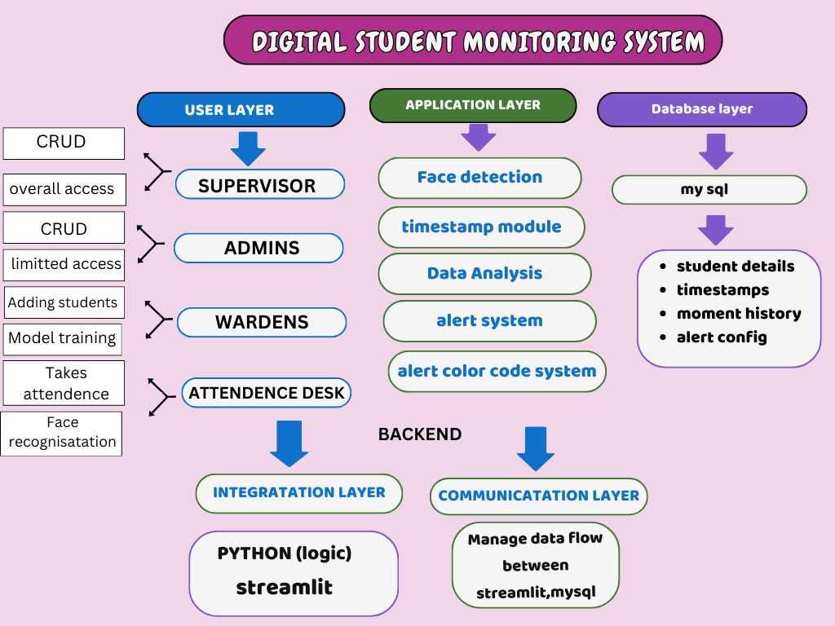

**Figure 4.1: Architecture of the Proposed System**

The Digital Student Monitoring System consists of three layers: User Layer, Application Layer, and Database Layer, connected by a backend. The User Layer includes Supervisors (full crud access), Admins (limited crud and model training), Wardens (monitoring), and the Attendance Desk (face recognition for attendance). The Application Layer handles face detection, timestamping, data analysis, alerts, and a color-coded status system. The Database Layer uses MySQL to store student details, timestamps, movement history, and alerts. The backend integrates Python (logic) and Streamlit (frontend) to ensure smooth data flow and an efficient, user-friendly experience.

**4.2 System Flowchart**

A system flowchart is a way of depicting how data flows in a system and how decisions are made to control events. Figure 4.2 depicts the system flowchart.

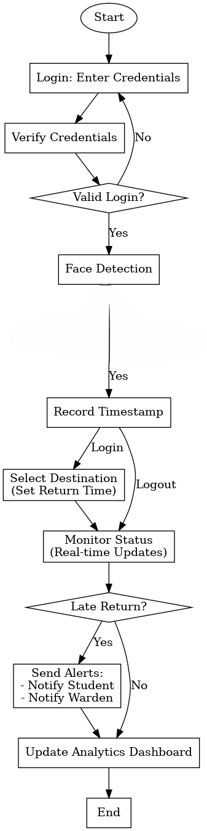



**Figure 4.2: System Flowchart**

Figure 4.2 outlines a system for managing and monitoring user activities through secure login, real-time tracking, and analytics. The process begins with users entering their credentials, which are verified for accuracy, followed by facial detection to confirm identity and record a timestamp. Upon logging in, users select their destination and set a return time, enabling the system to monitor their real-time status. If users return on time, the process continues seamlessly; otherwise, alerts are triggered to notify both the user and a warden, ensuring accountability. The system also updates an analytics dashboard with relevant data, such as timestamps, activities, and alerts, providing a centralized platform for tracking and analysis. This structured workflow ensures a secure, monitored, and well-documented process.

**4.3 Schema Diagram**

A system flowchart illustrates the flow of data within a system and outlines how decisions guide the control of events. The diagram below demonstrates the system's data flow and relationships among its components. Figure 4.3 depicts the schema diagram.

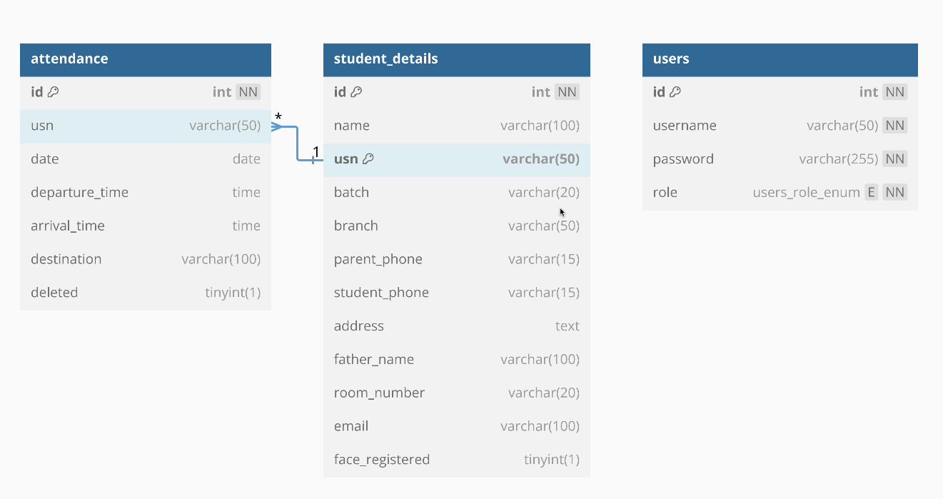

**Figure 4.3: Schema diagram**

**Queries**

CREATE TABLE attendance (

id int PRIMARY KEY NOT NULL AUTO_INCREMENT,

usn varchar(50) DEFAULT null,

date date DEFAULT null,

departure_time time DEFAULT null,

arrival_time time DEFAULT null,

destination varchar(100) DEFAULT null,

deleted tinyint(1) DEFAULT '0'

);

CREATE TABLE student_details (

id int NOT NULL AUTO_INCREMENT,

name varchar(100) DEFAULT null,

usn varchar(50) DEFAULT null,

batch varchar(20) DEFAULT null,

branch varchar(50) DEFAULT null,

parent_phone varchar(15) DEFAULT null,

student_phone varchar(15) DEFAULT null,

address text,

father_name varchar(100) DEFAULT null,

mother_name varchar(100) DEFAULT null,

room_number varchar(20) DEFAULT null,

email varchar(100) DEFAULT null,

face_registered tinyint(1) DEFAULT '0',

PRIMARY KEY (id, usn)

);

CREATE TABLE users (

id int PRIMARY KEY NOT NULL AUTO_INCREMENT,

username varchar(50) NOT NULL,

password varchar(255) NOT NULL,

role ENUM ('Supervisor', 'Admin', 'Warden', 'Attendance Desk') NOT NULL

);

CREATE INDEX usn ON attendance (usn);

CREATE UNIQUE INDEX unique_student ON student_details (usn);

CREATE INDEX idx_usn ON student_details (usn);

CREATE UNIQUE INDEX username ON users (username);

ALTER TABLE attendance ADD CONSTRAINT attendance_ibfk_1 FOREIGN KEY (usn) REFERENCES student_details (usn);

The provided SQL script defines the structure of three tables: attendance, student_details, and users, along with their relationships and constraints. The attendance table tracks student attendance details, including departure and arrival times, destination, and a soft delete flag (deleted). The student_details table stores comprehensive information about students, such as their name, USN (unique identifier), contact details, room number, and whether their face has been registered for recognition. The users table manages system user accounts with roles like Supervisor, Admin, Warden, and Attendance Desk. Unique and non-unique indexes are created to optimize search queries, such as the usn index on attendance and a unique index on student_details for usn to ensure each student's USN is distinct. Finally, a foreign key constraint links the attendance table's usn field to the student_details table, ensuring referential integrity by allowing only valid student USNs in the attendance table.

**Chapter 5**

**System Implementation**

The project is built with the agile development approach focusing on iterative improvement and continuous feedback. It utilizes SQL to manage the database, Streamlit for the interface of the application, and OpenCV with the Haar Cascade algorithm for real-time face recognition. MySQL is the used backend database for managing all the data regarding students and attendance as well as face recognition. This ensures that queries execute quickly and relevant information is available with ease. The frontend, using Streamlit, has built an intuitive and interactive interface for administrators and supervisors in managing student registrations, monitoring attendance, and producing reports. The face recognition functionality uses OpenCV's Haar Cascade algorithm to detect faces and automatically marks attendance once there is a match. This data is then uploaded to the MySQL database to be analysed and reported on, resulting in a fully integrated workflow. Continuous testing and refining ensure that the system functions and remains accurate throughout its development.

**5.1 System Features**

The system provides an end-to-end solution for attendance management, student registration, and tracking in real-time. There is a module for registering students, which enables administrators to input information such as names, USNs, contact numbers, and room assignments. The system also takes and stores student face images for later use in facial recognition. A prominent feature is the automatic attendance marking system, which uses the Haar Cascade algorithm in real-time to detect a face and match it up with the stored data thus eliminating manual attendance processes. It further enhances accuracy as it can track the exit and re-entry times for students, and it does record the destination when exiting. Attendance data is safely stored in the MySQL database; thus, generating reports as detailed as needed, sorted by date, student name, or time period-based criteria can be done promptly. Access to a dash board that provides information, management, and reporting opportunities for attendance records and user-roles management is accessible for all administrators and supervisors. With these functions working in correlation, error possibility decreases while the efficiency of tracking attendance increases significantly.

**5.2 Algorithms and Techniques**

The Haar Cascade face detection algorithm and the Local Binary Pattern Histogram (LBPH) face recognition algorithm make up a fundamental part of the system's functionality. Haar Cascade detects the face in real-time, using feeds from the webcam, effectively operating under all lighting conditions and angles. After that, the LBPH algorithm will identify who the face belongs to base on its local features that are matched against images taken of the students registered into the system. This ensures it performs well and strongly under real-world conditions. It uses SQL queries to engage with the MySQL database; this will allow retrieving students' details, marking attendance, and managing modifications made to data. Streamlit allows one to develop an interactive web application which accommodates real-time data entry, processing, and reports generation with no hassle from the back end. These algorithms and techniques are pivotal in achieving real-time functionality and reliable attendance management.

**5.3 Coding Standards and Practices**

The system is developed with strict adherence to coding standards and best practices, ensuring maintainability, security, and readability. The codebase follows a modular structure, with clearly defined functions dedicated to tasks like face detection, attendance recording, and database interactions. This modularity simplifies debugging and makes updates straightforward. Comprehensive error handling is implemented to ensure smooth running even when unexpected problems arise, such as database connection failure or camera malfunction. The code is thoroughly documented with comments explaining the purpose and functionality of each section, allowing for ease of understanding and future scalability. Security best practices include parameterized SQL queries to prevent SQL injection attacks and proper handling of sensitive data. These practices collectively ensure that the system is robust, secure, and ready for deployment in real-world environments.

**5.4 Pseudocode**

// Start Application

Initialize application

Check session state to determine if the user is logged in

// IF user is not logged in:

Redirect to Login Page

// ELSE:

Load Dashboard Based on User Role (Supervisor, Admin, Warden, Attendance Desk)

// Login Process

Display login page with fields for username and password

Validate user credentials (check against database)

// IF credentials are valid:

Set session state

Redirect user to their respective dashboard based on role

// ELSE:

Display "Invalid Login" error message

// Supervisor Dashboard

Display Supervisor Dashboard options:

1. Manage Student Attendance

2. Generate Reports

// IF user selects "View Student Attendance":

Display filter options to select student and date range

Fetch attendance records from the database

// IF records exist:

Display records in table format

// ELSE:

Display "No Records Found" message

// IF user selects "Generate Attendance Report":

Allow the user to select a student and date range

Generate report based on selection

Provide option to download the report as CSV

// IF user selects "Delete Attendance Record":

Allow the user to input attendance record ID to delete

Update the record’s status as "Deleted" in the database

// Admin Dashboard

Display Admin Dashboard options:

1. View Attendance Records

2. Delete Attendance Records

3. Manage Students

// IF user selects "View Attendance Records":

Display filter options for student and date range

Fetch and display records from the database

// IF user selects "Delete Attendance Record":

Allow the user to input attendance record ID to delete

Update the record’s status as "Deleted" in the database

// IF user selects "Manage Students":

Allow the admin to:

1. Add New Students

2. Edit Student Details

Validate inputs to prevent duplicate USNs

Handle errors during the student creation process

// Warden Dashboard

Display Warden Dashboard options:

1. View Student Attendance

2. Generate Attendance Report

3. Add New Students

4. Take Photos for Training

// IF user selects "View Student Attendance":

Allow the user to filter by student and date range

Fetch and display attendance records

// IF user selects "Generate Attendance Report":

Allow the user to select a student and date range

Generate report and provide download option as CSV

// IF user selects "Add Student":

Display form to add new student

Validate inputs to ensure no duplicate USN

Add new student to the database

// IF user selects "Take Photos for Training":

Fetch list of students without registered face data

Capture photos of the student using webcam

Train the face recognition model with captured images

// Attendance Desk Dashboard

Display Attendance Desk Dashboard options:

1. Start Face Scan for Attendance

// IF user selects "Start Face Scan":

Capture the student’s face using the webcam

Recognize the student’s face using the trained model

// IF student is departing:

Prompt user to input destination

Mark departure time in the database

// ELSE IF student is returning:

Mark return time in the database

Check for late returns and trigger alerts if necessary

Display confirmation message after marking attendance

// Alert System (Automated)

// IF student does not return on time:

Trigger email alert to the student and warden

Mark student as "Late" in the database

// Logout Process

Allow user to log out

Clear session state

Redirect to Login Page

// End Application

**Chapter 6**

**Testing and Validation**

**6.1 Testing Strategies**

Testing plays a crucial role in ensuring the reliability, performance, and correctness of the system. The testing strategy for this project combines unit testing, integration testing, system testing, performance testing, and usability testing. Unit testing focused on verifying the functionality of individual components, such as face detection, attendance marking, and database interaction. Each function was tested in isolation to ensure proper performance. After unit testing, integration testing was conducted to verify that various components, including the MySQL database, OpenCV face recognition, and the Streamlit frontend, interacted seamlessly. System testing was performed to assess the overall performance and end-to-end functionality of the system. This included testing the complete workflow, from student registration to attendance marking and report generation. Performance testing evaluated the system's ability to handle multiple users and real-time face recognition. Finally, usability testing focused on evaluating the user interface to ensure that administrators and supervisors could easily navigate the system and access all features.

**6.2 Test Cases and Results**

Test cases were designed to validate different aspects of the system's functionality. One important test case involved student registration, where the system was tested by adding student details, including face images, to the database. The system passed this test successfully by accurately storing the student information and face images for future use in face recognition. Another key test case involved face recognition for attendance, testing the system’s ability to detect and recognize the faces of registered students and mark their attendance. The system passed this test, as face detection and recognition performed well under normal lighting conditions. Attendance record creation was also tested to ensure that the system correctly recorded departure and arrival times for students, including capturing destination information when students were departing. The test for report generation confirmed that the system could generate accurate attendance reports based on various filters such as student name, date, and time. The system was also tested for invalid face recognition, where unregistered faces were properly handled by displaying an error message and not marking attendance. Finally, database handling was tested under load conditions to verify that the system could process multiple concurrent queries efficiently, which was successfully achieved without delays or failures.

**6.3 Validation and Verification**

Validation and verification were key to ensuring that the system met its intended purpose and satisfied project requirements. Functional validation confirmed that the system performed all necessary tasks, such as student registration, attendance marking, and report generation, accurately. Each feature worked correctly in different test scenarios. Data validation ensured that input data, such as student USNs and contact information, were formatted properly and correct. The system also validated the integrity of data stored in the database, raising appropriate warnings for incomplete or incorrect entries. Feedback from these tests contributed to enhancing the user interface and overall experience. The face recognition functionality was tested in real-world conditions with students under varying lighting conditions and facial expressions, and the system performed well, detecting and recognizing faces accurately. Lastly, security verification ensured the system was secure and free from potential vulnerabilities, such as SQL injection. The use of parameterized queries for database interaction and secure handling of sensitive data helped mitigate security risks.

**Table 6.1: Login and Password Testing and Validation**

|  |  |  |  |  |
| --- | --- | --- | --- | --- |
| **Sl. No.** | **Input** | **Expected Output** | **Obtained Output** | **Remarks** |
| 1 | Valid Password (correct credentials) | Login successful, user directed to the respective dashboard | Login successful, user redirected to dashboard based on their role (Supervisor, Admin, etc.) | P |
| 2 | Invalid Password (wrong password) | Error message: "Incorrect password" | Error message displayed: "Incorrect password" | P |
| 3 | Password input with special characters | Login successful (if valid credentials) | Login successful if credentials are correct, special characters should be handled properly. | P |
| 4 | Password input with spaces | Error or handled input (if there are restrictions on spaces) | Should trim spaces before checking validity, or error message if not allowed. | P |
| 5 | Empty Password field | Error message: "Password is required" | Error message displayed: "Password is required" | P |
| 6 | Password input with incorrect case (case sensitivity) | Error message: "Incorrect password" | Error message displayed: "Incorrect password" | P |
| 7 | Password input exceeding length limits | Error message: "Password too long" or trimmed input | Error message displayed if password exceeds length limit, or trimmed input. | P |
| 8 | Password Mismatch during registration/reset | Error message: "Passwords do not match" | Error message displayed: "Passwords do not match" | P |
| 9 | Password Reset Functionality | Password successfully reset and user able to log in with new password | User can reset their password and log in with the new credentials | P |

**Table 6.2: Face recognition and Attendance Testing and Validation**

|  |  |  |  |  |
| --- | --- | --- | --- | --- |
| **Sl. No.** | **Input** | **Expected Output** | **Obtained Output** | **Remarks** |
| 1 | Valid Student (face recognized) | Attendance marked as "Departing" or "Returning", with the correct details (USN, name, etc.) | Successful attendance marking with correct details (Departure/Arrival time and Destination) | P |
| 2 | Invalid or Unknown Student (face not recognized) | Error message: "Student not recognized" | Error message: "Student not recognized" displayed. | P |
| 3 | Face Recognition for Departing Student (with destination) | Attendance marked with destination and time of departure | Successful attendance marking with correct departure time and destination. | P |
| 4 | Face Recognition for Returning Student (no destination) | Attendance marked with arrival time only, no destination | Successful marking of arrival time for returning students. | P |
| 5 | Multiple Students in the Camera Frame | Attendance marked for the first recognized student, others ignored | The first recognized student’s attendance is marked, and others are not processed until recognized. | P |
| 6 | Face Recognition with Low Confidence (uncertain match) | Error message: "Unknown" or low-confidence recognition handled properly | The system should either handle the uncertain match gracefully (e.g., flag as unknown) | P |
| 7 | Face Recognition with Obstruction (e.g., face partially covered) | No attendance marked or error message displayed | Error or no attendance recorded if the face is partially obstructed (e.g., due to mask, hand, etc.). | P |
| 8 | Face Recognition on Unregistered Student | Attendance not marked, error message displayed | Error message displayed: "Student not registered" or attendance not marked for unregistered students. | P |
| 9 | Multiple Unregistered Faces Detected | Error message: "No registered student detected" | Error message: "Student not recognized" for each unregistered face. | P |
| 10 | Student with Registered Face, Not Registered for Attendance (e.g., not marked for today) | Attendance not marked, error message "Already marked today" or similar | Attendance not marked if the student has already marked their attendance for the day (either departing or returning). | P |
| 11 | Face Registration for New Student | Success message: "Face registered successfully" | Face is registered and stored correctly in the system. | P |
| 12 | Attempt to Train Model without Registered Faces | Error message: "No registered faces found" | Error message displayed when attempting to train the model without registered faces. | P |

**Chapter 7**

**Results and Discussions**

**7.1 Outputs of the Project**

Figure 7.1 is the login page for Supervisor, Admin, Warden to the web application.

**Figure 7.1: Login Page**

Figure 7.2 is the Dashboard page for Supervisor of web application. This section includes the management of the users of the application and see the deleted records.

**Figure 7.2: Supervisor dashboard**

Figure 7.3 is the View attendance section of the supervisor of the web application.

**Figure 7.3: View Attendance Section**

Figure 7.4 is the overtime monitoring settings for the email sending feature of the web application.

**Figure 7.4: Overtime Setting Page**

Figure 7.5 is the Admin dashboard of web application.

**Figure 7.5: Admin Dashboard**

Figure 7.6 is the warden dashboard of web application.

**Figure 7.6: Warden Dashboard**

Figure 7.7 is the form for adding students to the hostel by the warden.

**Figure 7.7: Add Student Form**

Figure 7.8 is the section used to train and take pictures of the added students for the face recognition model.

**Figure 7.8: Picture Clicking and Training Section**

Figure 7.9 is the section where it shows an interactive pie chart to see students movement based on the date.

**Figure 7.9: Attendance Pie Chart**

Figure 7.10 shows the section of the attendance desk where it logs in and out the students.

**Figure 7.10: Attendance Desk Section**

**7.2 Performance Analysis**

**Table 7.1: Unit test cases**

|  |  |  |
| --- | --- | --- |
| **Test Case No.** | **Input** | **Expected behavior** |
| 1 |  | The result should appear as expected user interface |
| 2 |  | Supervisor Dashboard |
| 3 |  | Sends E-mail to late students |
| 4 |  | Admin Dashboard |
| 5 |  | Warden Dashboard |
| 6 |  | Adding Students |
| 7 |  | Face Capture |
| 8 |  | Face Recognition & Login-Logout |

* 1. **Comparisons with Existing Solutions**

**Table 7.1: Comparison test cases**

|  |  |  |
| --- | --- | --- |
| **Feature/Aspect** | **Existing Solutions** | **Proposed System** |
| Technology | Manual register systems or biometric systems without face recognition. | Advanced system using Haar Cascade face detection integrated with real-time alerts. |
| Automation | Minimal automation, manual data entry, and timestamping. | Fully automated process for student entry/exit, timestamps, and data analysis. |
| Accuracy | Susceptible to errors due to manual interventions or reliance on physical signatures. | Accurate identification of students using face detection technology with minimal chances of error. |
| Database Integration | Limited or no integration with centralized databases. | Integrated with MySql, enabling real-time updates and centralized record-keeping. |
| Notifications & Alerts | No notification system for delays or unauthorized movements. | Real-time email alerts for late returns or unauthorized activities. |
| Ease of Use | Manual systems or biometric terminals are cumbersome and time-consuming for students and staff. | User-friendly system accessible via web application, ensuring convenience for students and wardens. |
| Cost-Effectiveness | Biometric systems may be costly and require additional hardware. | Cost-effective as it uses existing webcams, open-source libraries, and a cloud-based solution. |
| Security | Data may be vulnerable due to lack of encryption or centralized storage. | Secure cloud storage with access control, ensuring the privacy of student records. |

The Student Movement Monitoring System outperforms existing solutions by automating student tracking with face detection, real-time alerts, and cloud integration for centralized data management. It offers customizable workflows, proactive monitoring, and detailed analytics, ensuring accuracy and scalability. Compared to manual and biometric systems, it is more secure, user-friendly, and cost-effective.

**Chapter 8**

**Conclusion and Future Enhancements**

The Digital Student Movement Monitoring System provides a robust and efficient solution to track and manage the movement of students in and out of a hostel. By integrating face recognition technology, the system automates the login and logout processes, ensuring accuracy and reducing the possibility of human error. The system captures timestamps upon login and logout, allowing for precise tracking of student activity. In cases of delayed returns, automatic alerts are sent to both the students and the warden, ensuring timely intervention. This system not only improves the operational efficiency of hostel management but also enhances security by monitoring student movements in real-time. Additionally, the data analysis feature enables the warden to easily review the status of students, including how many are out, their destinations, and whether they are returning on time. This facilitates better decision-making and enhances the overall safety and management of hostel facilities.

Overall, this project demonstrates the power of integrating computer vision and machine learning with practical applications in real-world scenarios, offering a smarter and more automated solution for student movement tracking and hostel management.

**8.1 Future Enhancements**

The Digital Student Movement Monitoring System has significant potential for further enhancement and expansion. Future improvements could include:

**Integration with Mobile Apps**: Developing a mobile application to allow students and wardens to access real-time updates, notifications, and reports on their smartphones, making the system more accessible and user-friendly.

**AI-Based Predictions:** Incorporating machine learning algorithms to predict student behavior, such as identifying patterns of late returns or potential risks, which can help the warden take proactive actions.

**Integration with RFID:** Combining face recognition with RFID technology to create a hybrid system that can track students' movements more accurately, especially in large hostels.

**Cloud Integration:** Storing the data on a cloud platform to ensure easy access, scalability, and backup, allowing data to be accessed from any location.

**References**

[1] Gurlove Singh and Amit Kumar Goel, "Face Detection and Recognition System using Digital Image Processing," *propose that face recognition is a biometric technology used for identity authentication based on facial features, 2020.*

[2] Lixiang Li, Xiaohui Mu, Siying Li, and Haipeng Peng, "A Review of Face Recognition Technology," *2020.*

[3] Maliha Khan, Sudeshna Chakraborty, Rani Astya, and Shaveta Khepra, "Face Detection and Recognition Using OpenCV," *The paper discusses the use of Principal Component Analysis (PCA) for facial recognition,* *2019.*

[4] Devang Sharma, Himanshu Sharma, and Dipesh Panchal, "Automatic Office Environment System for Employees Using IoT and Computer Vision," *using face recognition and Amazon Web Services (AWS) like S3 and Quick Sight,* *2020.*

[5] Samuel Lukas, Aditya Rama Mitra, Ririn Ikana Desanti, and Dion Krisnadi, "Student Attendance System in Classroom Using Face Recognition Technique, " *2016*

[6] Fadi Masalha and Nael Hirzallah, "A Students Attendance System Using QR Code," *2024*

[7] Samridhi Dev and Tushar Patnaik, "Student Attendance System using Face Recognition," *It integrates techniques like Haar classifiers, KNN, CNN, SVM, Generative Adversarial Networks (GANs), and Gabor filters to perform face recognition,* *2020.*

[8] Kritagya Painuly, Yukti Bisht, Himadri Vaidya, Akanksha Kapruwan, and Rupesh Gupta, "Efficient Real-Time Face Recognition-Based Attendance System with Deep Learning Algorithms," *2024*

[9] Marko Arsenovic, Srdjan Sladojevic, Andras Anderla, and Darko Stefanovic, "FaceTime — Deep Learning Based Face Recognition Attendance System," *2017*

[10] Susanta Kumar Sarangi, Arunesh Paul, Harshit Kishor, and Kritath Pandey, "Automatic Attendance System using Face Recognition," *address the challenges of manual attendance systems in educational institutions, particularly in virtual platforms,* *2013.*

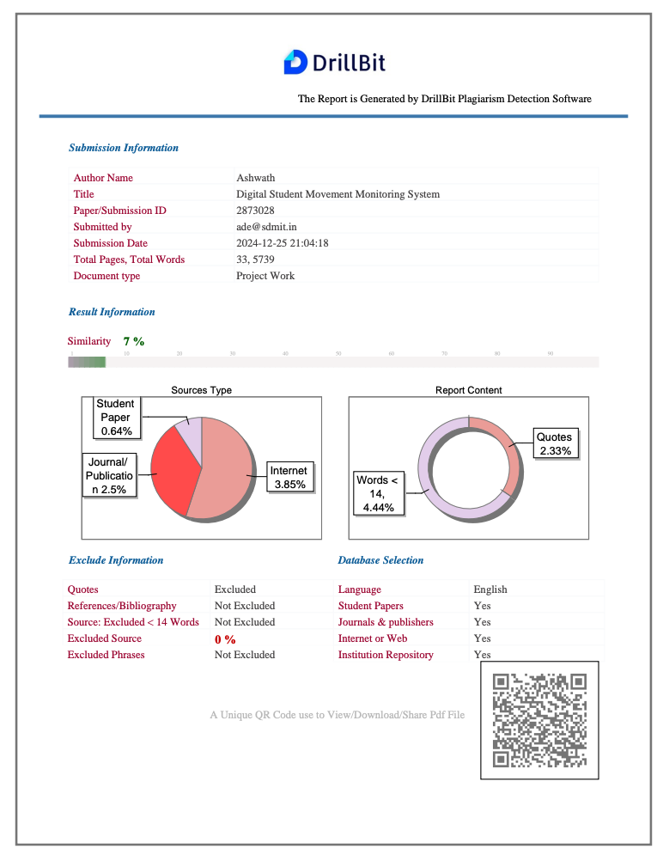**Plagiarism Report**

**Personal Profile**

|  |  |
| --- | --- |
| **Mr. Amith K S**  Asst. Prof.  Project Guide | **Mr. Amith K S** is an accomplished professional with a strong academic and industrial background. He holds a BE in Computer Science from AIT Chickmagalore and an M.Tech in Network and Internet Engineering from JNNCE Shimoga, and is currently pursuing a PhD on Security in 5G and beyond in collaboration with TCS. A member of MISTE, he has substantial experience in various domains, combining industry expertise with academic rigor.  Amith has delivered numerous talks and hands-on workshops at colleges, focusing on crucial and emerging technologies. As the founder of a startup, he brings entrepreneurial spirit to his endeavors. His certifications in ColdFusion, AS400, and Six Sigma Yellow Belt, alongside recognition from Buffalo University, USA, for blockchain smart contract auditing, underline his technical expertise. Additionally, Amith is passionate about agriculture, reflecting a diverse range of interests and capabilities.  Email ID: amith.kashyap@sdmit.in  Name: Ashwath G Bhat  USN: 4SU21AD009  Address: Manjunatha Nilaya, Shanthi Nagar, Ujire  E-mail ID: bhatashwath120@gmail.com  Contact Phone No: 8431036619 |
|  | Name: Deviprasad  USN: 4SU21AD016  Address: Kollipal House, Killur Post, Belthangady  E-mail ID: kollipaldeviprasadrao@gmail.com  Contact Phone No: 7760266232 |
|  | Name: Prabhu Gouda Patil  USN: 4SU22AD401  Address: Dajiban peth Saloni, Hubli  E-mail ID: xdrprabhu@gmail.com  Contact Phone No: 8792405147 |

|  |  |
| --- | --- |
|  | Name: Yathiraj  USN: 4SU22AD403  Address: Savanalu, Savanalu Post, Belthangady  E-mail ID: yathiraj897@gmail.com  Contact Phone No: 8971722653 |